
Company
Logotype

Cone Beam Computed Tomography- Report



Porur Dental X-rays & CBCT

Patient Name : Mrs. Shanthi | Date of Report : 08.08.2024
Age/ Gender : 53 years/ Female | Region of Interest : CBCT Full Skull
Referring doctor: Dr. Elakya | Indication : Implant assessment
Clinical Notes: Nil
PATIENT INFORMATION

CBCT- Full Skull provided
CBCT – IMAGE DETAILS

RADIOGRAPHIC INTERPRETATION

- Complete loss of crown and root structure in relation to 18, 26, 28, 36,
- Root stumps in relation to 12, 46, 48.
- The alveolar ridge in relation to the maxillary and mandibular alveolar ridge is present with normal trabecular pattern.

IMPLANT ASSESSMENT

 | 11 region | 12 region | 13 region | 14 region | 21 region | 22 region | 23 region | 24 region
Sub-Crestal | 4.7 | 5.6 | 7.6 | 8.1 | 7 | 5.1 | 5.6 | 7.4
Mid- Crestal | 5.4 | 5.5 | 7.5 | 8.4 | 7.1 | 4.8 | 5.4 | 6.7
Distance between the alveolar ridge and Floor of the Nasal cavity (in mm) | 18.5 | 17.9 | 11.9 | 11.4 | 17.8 | 18.9 | 13.8 | 11.9

 | 15 region | 16 region | 17 region | 25 region | 26 region | 27 region
Sub-Crestal (in mm) | 6.2 | - | 13 | 7.5 | - | -
Mid- Crestal (in mm) | 7.8 | - | - | - | - | -
Distance between the alveolar ridge and floor of the maxillary sinus (in mm) | 6.3 | 3 | 3.8 | 1.8 | 0.8 | 2.9

 | 31 region | 32 region | 33 region | 34 region
Sub-Crestal (in mm) | 4.6 | 5.4 | 6.7 | 7
Mid- Crestal (in mm) | 4.8 | 5.7 | 6.6 | 8.1
Distance between alveolar ridge and the inferior border of mandible (in mm) | 27.8 | 26.3 | 25.3 | 26

 | 41 region | 42 region | 43 region | 44 region
Sub-Crestal (in mm) | 4.8 | 5.9 | 7.2 | 9
Mid- Crestal (in mm) | 5.5 | 6.8 | 7.5 | 8.7
Distance between alveolar ridge and the inferior border of mandible (in mm) | 25.6 | 21.2 | 18.5 | 21.8
 | 45 region | 46 region | 47 region
Sub-Crestal (in mm) | 7.9 | 11.1 | 10.2
Mid- Crestal (in mm) | 9.1 | 10.2 | 11
Distance between alveolar ridge and the inferior alveolar nerve canal (in mm) | - | 7 | 11.2
Distance between alveolar ridge and the inferior border of mandible (in mm) | 20.7 | 19.3 | 22.6

 | 35 region | 36 region | 37 region
Sub-Crestal (in mm) | 7.6 | 6.1 | 7.5
Mid- Crestal (in mm) | 8.3 | 7.4 | 8
Distance between alveolar ridge and the inferior alveolar nerve canal (in mm) | - | 14.4 | 10.4
Distance between alveolar ridge and the inferior border of mandible (in mm) | 23.1 | 25 | 23.2

RADIOGRAPHIC IMPRESSION

- Partially edentulous maxillary and mandibular arch.
- Root stumps in relation to 12, 46, 48.

Kindly correlate with clinical findings


IMAGES FOR REFERENCE

RECONSTRUCTED PANORAMIC VIEW
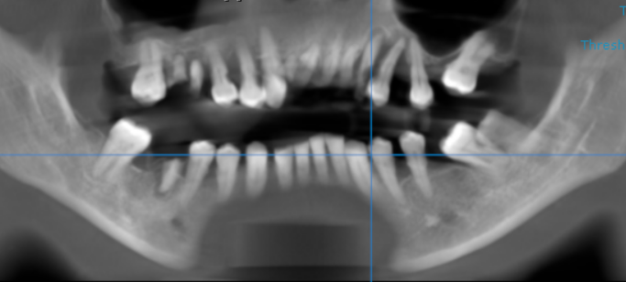

3-DIMENSIONAL VIEW
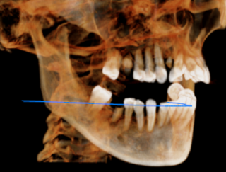

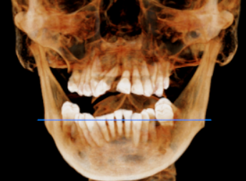

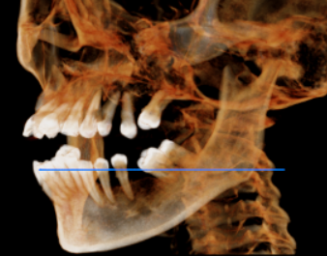

CROSS SECTIONAL VIEW

11 region | 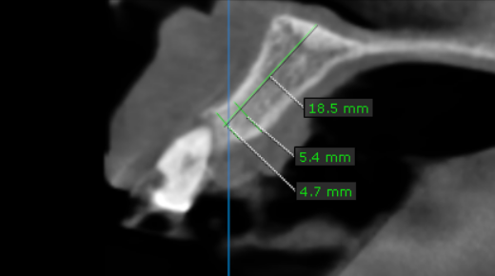
12 region | 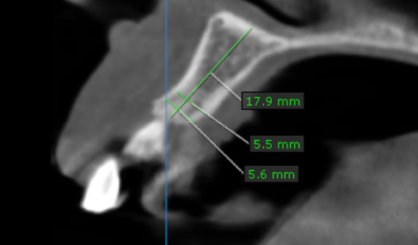
13 region | 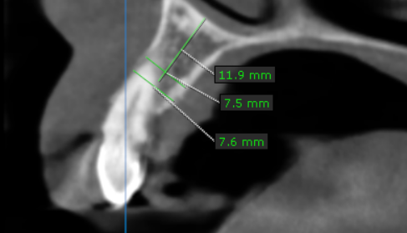
14 region | 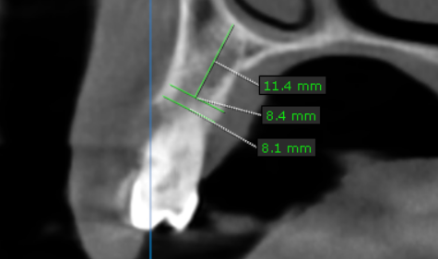
15 region | 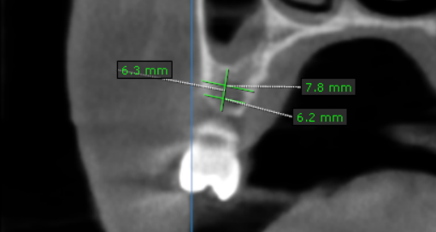
16 region | 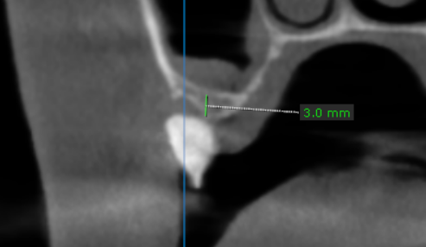
17 region | 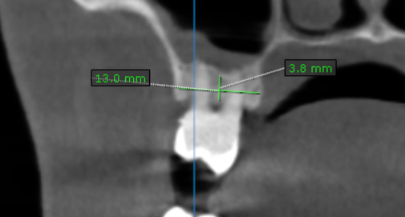
21 region | 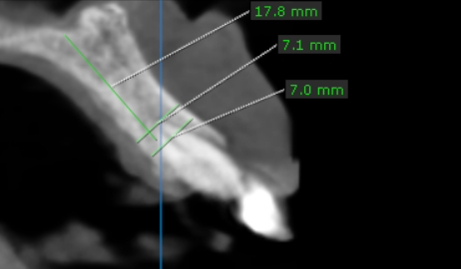
22 region | 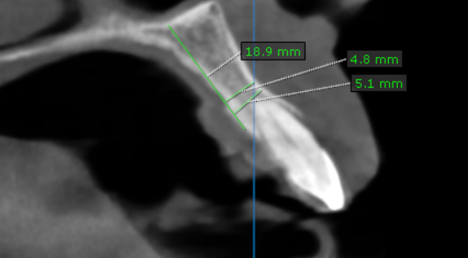
23 region | 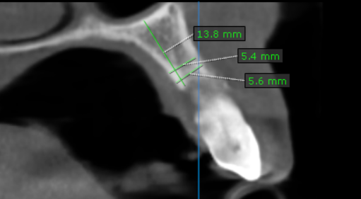
24 region | 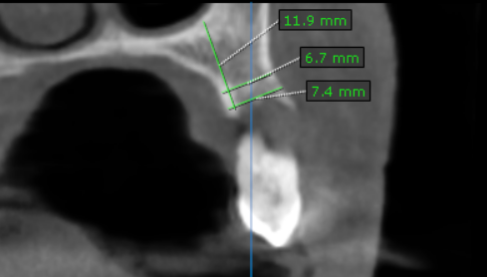
25 region | 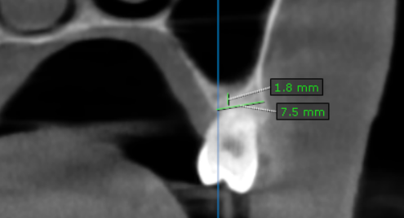
26 region | 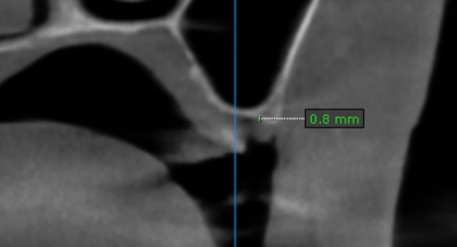
27 region | 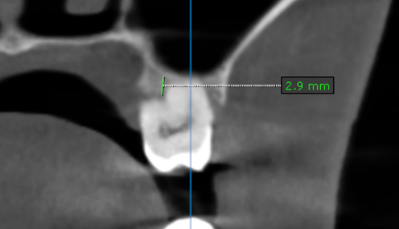
31 region | 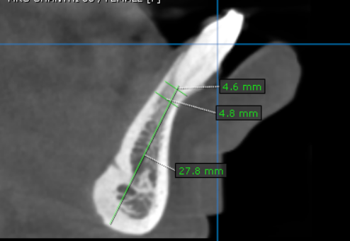
32 region | 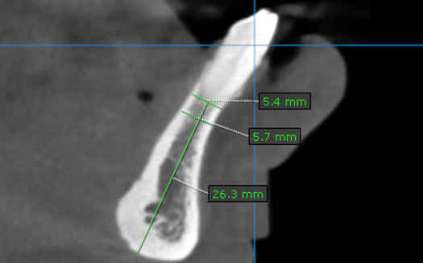
33 region | 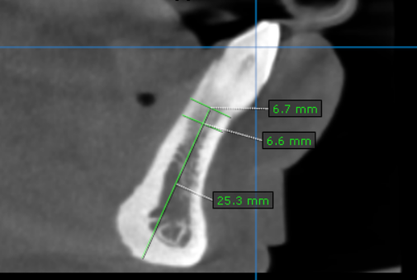
34 region | 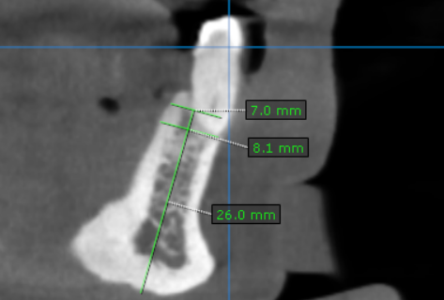
35 region | 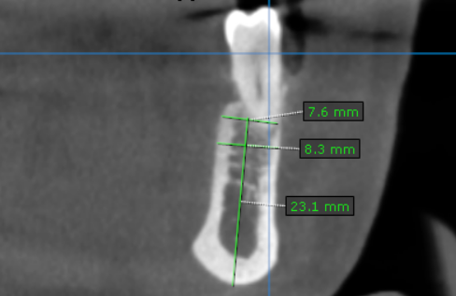
36 region | 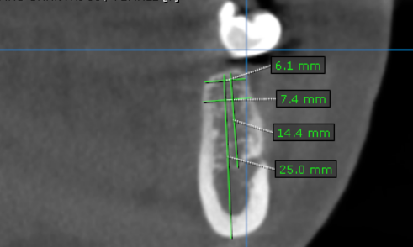
37 region | 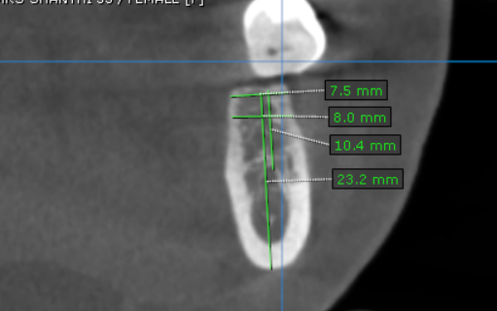
41 region | 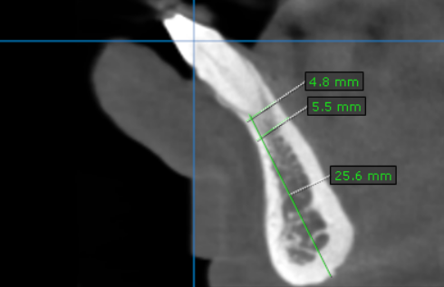
42 region | 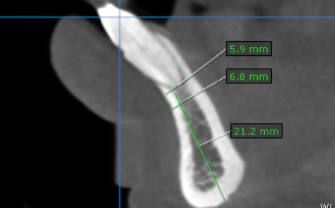
43 region | 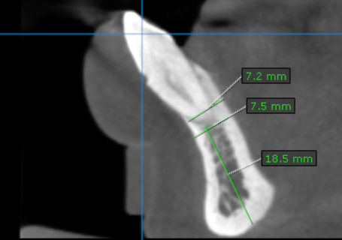
44 region | 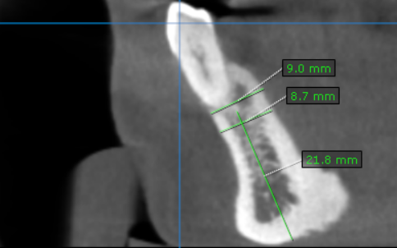
45 region | 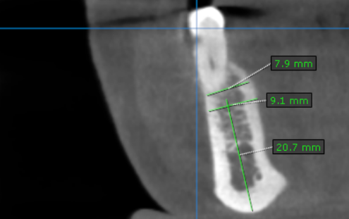
46 region | 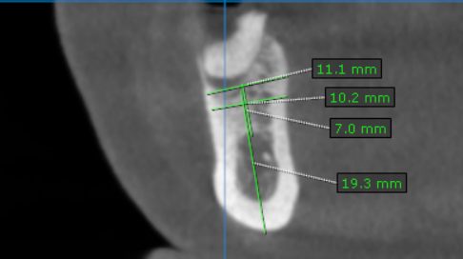
47 region | 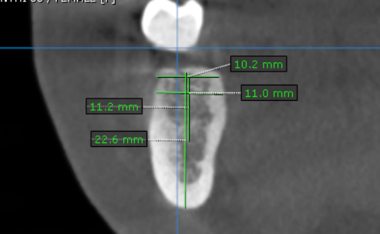

**** End of report ****

